Instructions for the CaptchaImageClick module

Table of contents

Instructions for solving ReCAPTCHA 2 *3*

*ReCAPTCHA 2 Normal 3*

*ReCAPTCHA 2 Invisible 4*

*ReCAPTCHA 2 Enterprise 7*

InstructionBydecisionhCaptcha *8*

*hCaptcha Normal 8*

*hCaptcha Invisible 10*

*hCaptcha Enterprise 14*

Instructions for solving FunCaptcha *15*

Instructions for solving TikTok *17*

Instructions for solving GeeTest *18*

Instructions for solving YandexSmart captcha *20*

**Instructions for solving ReCAPTCHA 2**

**ReCAPTCHA 2 Normal**

The most common type of ReCAPTCHA 2 is a captcha with the inscription " I'mnot a robot " ("I'm not a robot") and a checkbox in which you need to tick. We will call this captcha **ReCAPTCHA 2 Normal**

***Picture :***

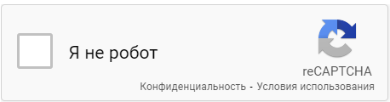

In order to solve this captcha, you need to select the selector of any part of the image specified above, for example, the text "I'm not a robot" or the checkbox to the left of it and place this selector in the module settings in the "Captcha selector" section. Please note that the selector that is already set by default in the module is suitable for 80% of captchas , but only if the site owner has not taken any action that changes the CSS layout of the captcha, in which case the selector must be created by yourself.

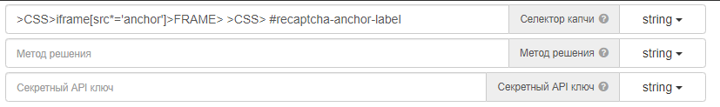

*The module will automatically click on the inscription " I'mnot a robot " ("I'm not a robot"), will open a window with captcha images and solve it. It will then return the result of the solution. You don't need to press anything else!*

In the advanced settings, you can adjust the click rate, the number of attempts to solve, as well as the position of the captcha. This is necessary if the original web page contains two or more captchas at once and solve the necessary second, third, etc.

**ReCAPTCHA 2 Invisible**

Since [2018,](https://wikireality.ru/wiki/2018_%D0%B3%D0%BE%D0%B4) a new version of Google captcha has appeared - **ReCAPTCHA 2 Invisible** . This is a hidden captcha that does not contain any " I'mnot a robot " ("I'm not a robot") and a checkbox in which you need to tick. It appears when you click on a button on the site, for example, the button " Register " .

***Picture :***

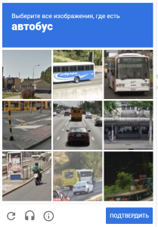

In order to solve such a captcha, you need to do a number of manipulations:

1. Check if the window with captcha images is open. There are situations when a site evaluates your browser session as a trust session and may not bring up this captcha window. Use the browser action *to check the existence of the element and* **only *after that*** *start solving the captcha using the module.*

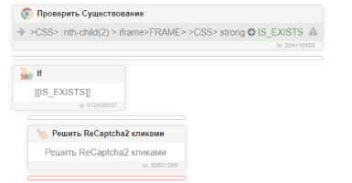

1. After you have made sure that the captcha window is open, you need to create a captcha selector, the universal selector that is present by default in the module will not work, it is not made for this type of captcha. In this case, you need to select any selector within the visible captcha window (task, image, etc. ) and place it in the selector field in the module settings. For example, we will select the task selector from the image above "Select all images where there is a bus"

**Example :**

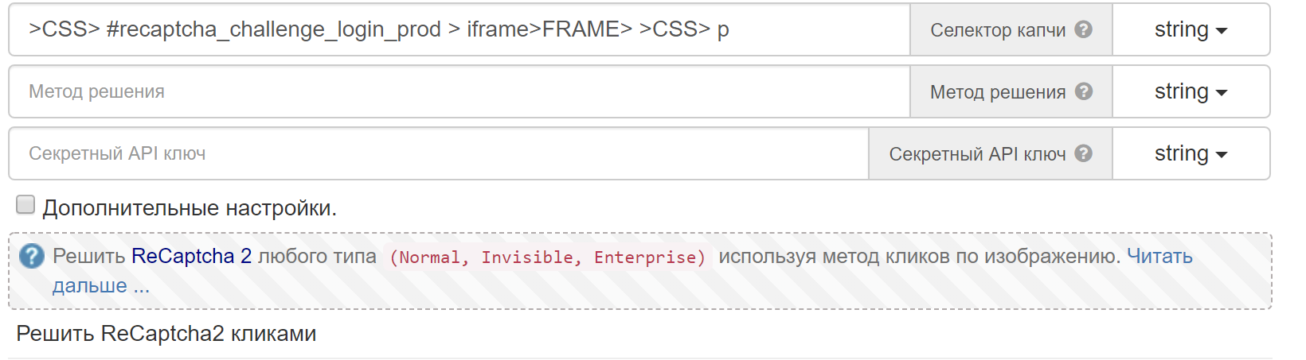

**The resultingSelector** : *>CSS > #recaptcha_challenge_login_prod > iframe>FRAME>>CSS> p*

Note! *On your site, the selector may differ from the one in the example! The first part of the selector is the unique selector for your site, the second part is the job selector.*

1. The next step that needs to be done is to specify the cache mask, by which we will get the captcha image. In the case of the Invisible version of the captcha, it opens in advance and the module simply has nowhere to get the cache, so you need to specify it yourself. You need to go to the section ***Network>Allow cache*** . Set the mask to ***recaptcha /*/ payload .*** *You need to place this action at the beginning of the template, for example, before loading the site where your captcha is located* .

**Action example :**

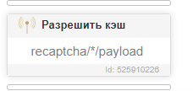

1. After we have done the above instructions, the last thing left is to go to the advanced settings and indicate that we are going to solve the Invisible captcha variant. It is necessary to set in the field "Is this an Invisible captcha variant?" the value is **" true ".** An example can be seen in the image below :

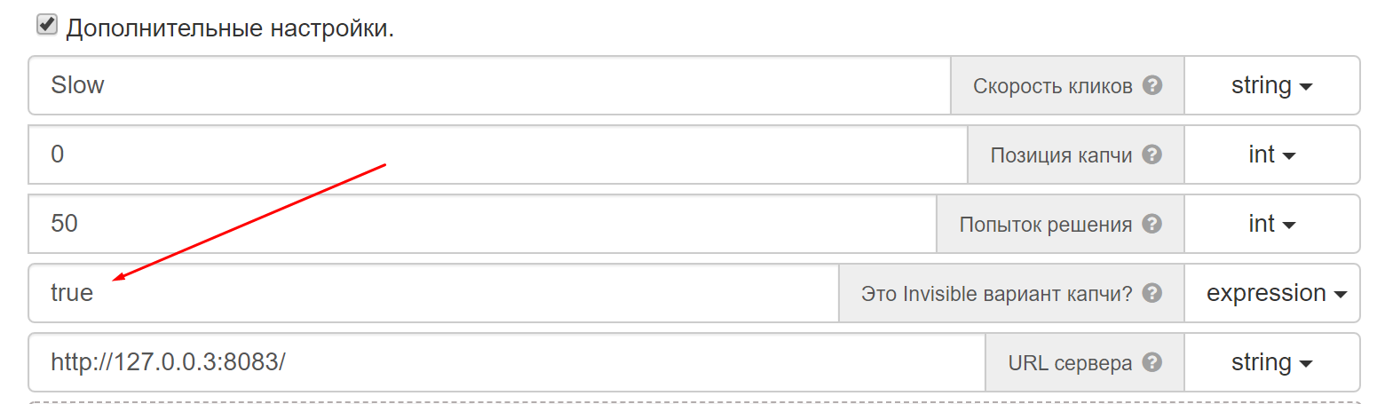

That's all. The module will now be able to solve your captcha. At the end, the final version of how to place the actions to solve the Invisible captcha solution will be demonstrated.

**The final example of a ReCAPTCHA 2 Invisible solution :**

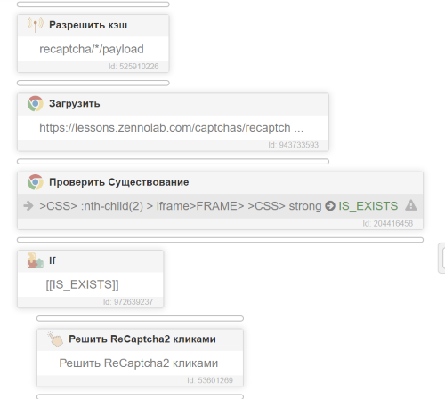

**ReCAPTCHA 2 Enterprise**

Since [2020,](https://wikireality.ru/wiki/2018_%D0%B3%D0%BE%D0%B4) another version of Google captcha has appeared - **ReCAPTCHA v2 EnterPrise .** This is a combination of two types of captcha: **Normal and ReCAPTCHAv 3**

The instruction for solving this captcha is no different from the Normal instruction of the ReCAPTCHA 2 type , except that this captcha blocks access to the site based on the analysis of user activity, using artificial intelligence to independently determine whether it is a bot or a person. Even if you correctly click on all captcha images, the site may return a captcha solving error.

In other words, it is not enough to correctly click on the picture of the captcha itself, you also need to go through some kind of captcha fraud . It is necessary to get high-quality proxies and a browser (fingerprints, their settings, possibly canvas , heated profile, etc. ). **Note:**

***The tasks of the module do not include searching for you high-quality proxies, fingerprints and a heated profile. The task of the module is only to correctly click on the images.***

Steam registration form : https://store.steampowered.com/join/

**Instructions for solving hCaptcha**

**hCaptcha Normal**

The most common type of hCaptcha is a captcha with the inscription " I'm a human " ("I am a Human") and a checkbox in which you need to tick. We will call this captcha **hCaptcha.Normal**

***Image:***

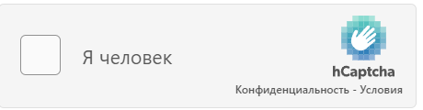

In order to solve this captcha, you need to select the selector of any part of the image specified above, for example, the text "I am Human" or the checkbox to the left of it and place this selector in the module settings in the "Captcha selector" section. **Please note** that the selector that is already set by default in the module is suitable for 80% of captchas , but only if the site owner has not taken any action that changes the CSS layout of the captcha, in which case the selector must be created by yourself.

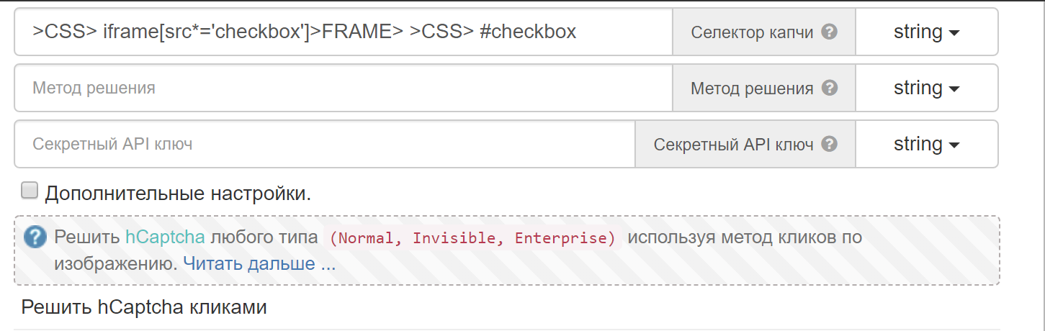

*The module will automatically click on the inscription " I'm a human " ("I am a Human"), open a window with captcha images and solve it. It will then return the result of the solution. You don't need to press anything else!*

In the advanced settings, you can adjust the click rate, the number of attempts to solve, as well as the position of the captcha. This is necessary if the original web page contains two or more captchas at once and solve the necessary second, third, etc.

***Please note*** that there are cases when only 1 captcha is visible on your site, but there are two of them in the html layout, and the first captcha is visually *hidden from the user* .

An example of such a site: <https://coinvote.cc/coin/Vapia-Coin>

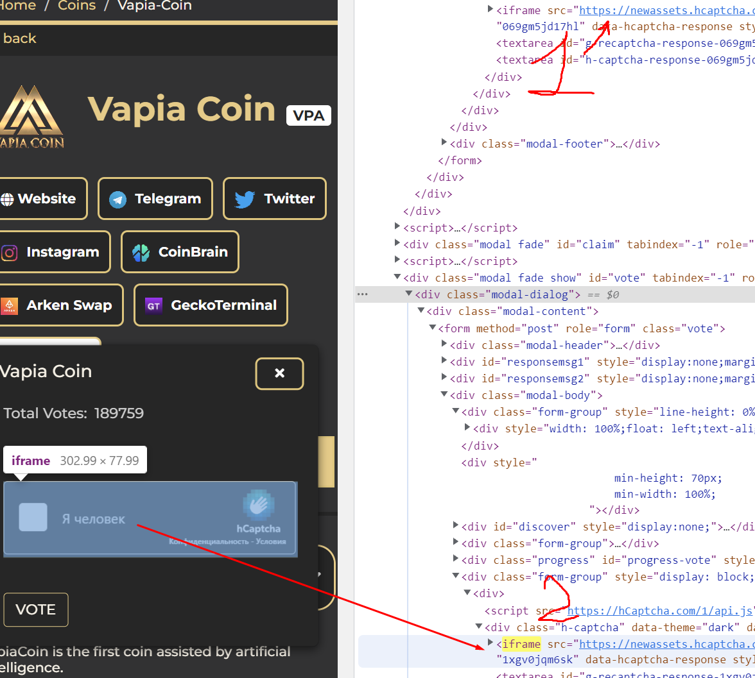

Therefore, in the additional settings, you must specify the position of this iframe (the countdown starts from zero, the first iframe is 0, the second is 1, etc.)

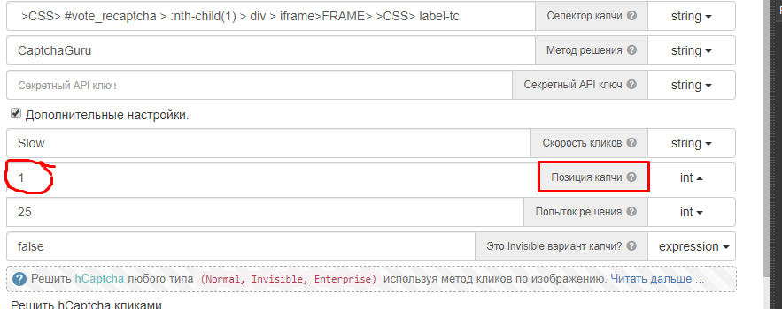

**hCaptcha Invisible**

There is another type of ***hCaptcha* –** *Invisible* version . This is a hidden captcha that does not contain any buttons " I'm a human " ("I am a Human") and a checkbox in which you need to tick. It appears when you click on a button on the site, for example, the "Register" button.

***Image:***

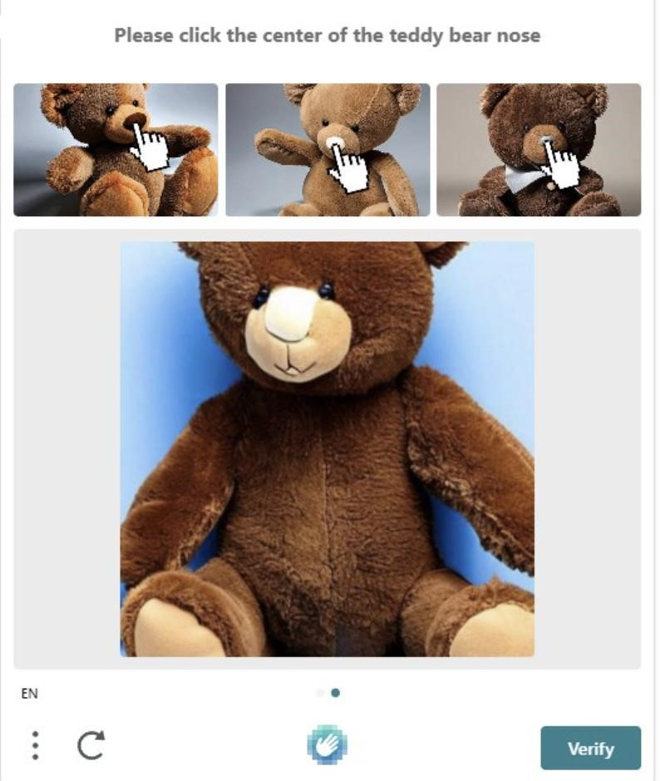

*In order to solve such a captcha, you need to do a series of*

*manipulations:*

1. Check if the window with captcha images is open. There are situations when a site evaluates your browser session as trustworthy and may not bring up this captcha window. Use the browser action *to check the existence of the element and* **only *after that*** *start solving the captcha using the module.* **Please note** *that* hCaptcha has a lot of task subtypes, so you need to choose a universal selector for all types of captchas (It will be discussed below) .

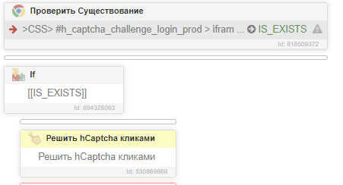

1. After you have made sure that the captcha window is open, you need to create a captcha selector, the universal selector that is present by default in the module will not work, it is not made for this type of captcha. ***Update 04/10/2023*** : Since hCaptcha has a lot of subtypes of tasks, it is necessary to choose a universal selector that will fit all types of captchas , for example, we can select the bottom of the captcha selector, where the update button is located, the hCaptcha logo and the button to confirm captcha solution. Captcha selector in iframe :

***>XPATH> //div[@class="interface-challenge"]***

In this case, you need to choose such a selector

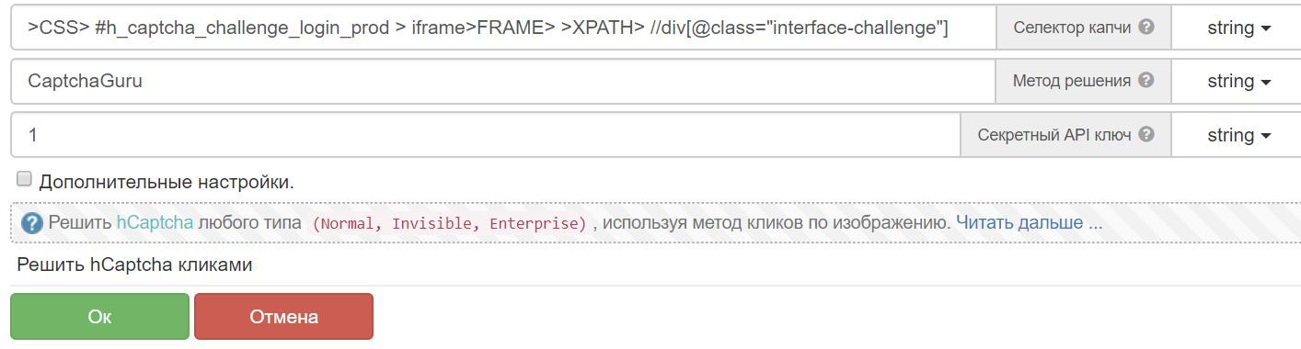

**The resultingSelector** : *>CSS > #h_captcha_challenge_login_prod > iframe>FRAME>****>XPATH> //div[@class="interface-challenge"]***

Note! *On your site, the selector may differ from the one in the example! The first part of the selector is the unique selector for your site, the second part is the bottom hcaptcha selector .*

1. The next action that needs to be done is to specify the cache mask, by which we will receive the captcha image, as well as the task. In the case of the Invisible version of the captcha, it opens in advance and the module simply has nowhere to get the cache, so you need to specify it yourself. You need to go to ***the Network >Enable Cache section*** and create 2 mask actions: ***\*imgs.hcaptcha.com/* and *hcaptcha.com/ getcaptcha \****

*You need to place these actions at the beginning of the template, for example, before loading the site where your captcha is located.*

**Example of two actions**

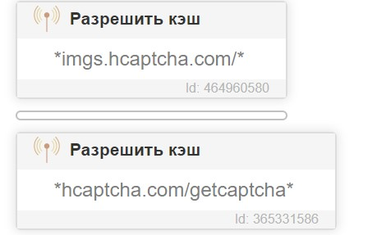

1. After we have done the above instructions, the last thing left is to go to the advanced settings and indicate that we are going to solve the Invisible captcha variant. It is necessary to set in the field " *Is this an Invisible captcha variant* ?" the value is **" true ".** An example can be seen in the image below:

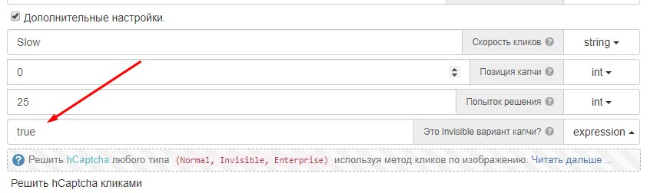

That's all. The module will now be able to solve your captcha. At the end, the final version of how to place the actions to solve the Invisible captcha solution will be demonstrated.

**Final example of hCaptcha solution Invisible :**

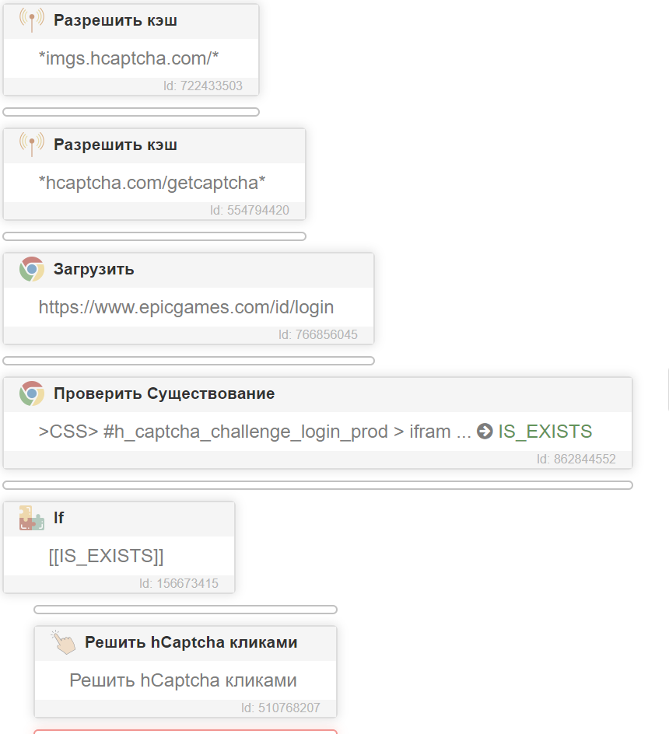

**hCaptcha Enterprise**

WITH [2020 _](https://wikireality.ru/wiki/2018_%D0%B3%D0%BE%D0%B4) there is another version **of hCaptcha - Enterprise**

The instruction for solving this captcha is no different from the Normal instruction of the hCaptcha type , except that this captcha blocks access to the site based on the analysis of user activity, using artificial intelligence to independently determine whether it is a bot or a person. Even if you correctly click on all captcha images, the site may return a captcha solving error.

In other words, it is not enough to correctly click on the picture of the captcha itself, you also need to go through some kind of captcha fraud . It is necessary to get high-quality proxies and a browser (fingerprints, their settings, possibly canvas , heated profile, etc. ). **Note:**

***The tasks of the module do not include searching for you high-quality proxies, fingerprints and a heated profile. The task of the module is only to correctly click on the images.***

***An example of such a site:*** hcaptcha on the authorization form of the epicgames site . This captcha consists of two varieties at once ( Invisible + EnterPrise )

Instructions for solving FunCaptcha

***fun captcha***– one of the most complex types of captchas presented in the module, there are no universal solutions and selectors. Each site can independently individualize this captcha and therefore fine-tuning for each individual site is necessary.

In this tutorial, an example of how to solve ***FunCaptcha for an outlook / amazon / github site , etc. will be analyzed.***

So let's go. In order to solve such a captcha, you need to do a number of manipulations:

1. *Determine how many tasks it is advisable for us to solve* . First, we need to decide for ourselves how many tasks we will click and for how many tasks it generally makes sense to pay. In the advanced settings, find the following parameter: *Maximum number of tasks and set the value you need.* Read more under the question mark what it means. By default, this value is 10

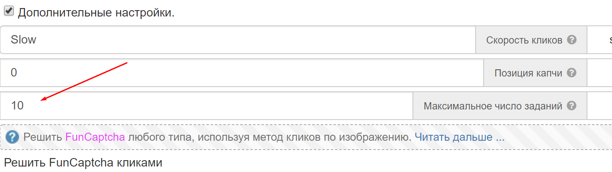

1. *Select selector* . It is necessary to select a button selector on the site that opens a window with a captcha and place it in the selector field in the module settings. **Example for outlook :**

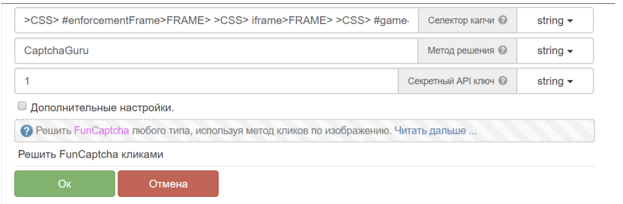

**The resultingselector** : *>CSS> #enforcementFrame>FRAME>>CSS> iframe>FRAME>>CSS> #game-core-frame>FRAME>>CSS> button[data-theme*=' verifyButton ' ]*

**Please note:** sometimes when solving FunCaptcha on the site, you may come across a dynamic selector from different types of captchas , in this case, you need to check in the loop which button selector was loaded in your case, set it to a variable, and then place this variable in the module setting " Captcha selector »

1. *Create cache* ***.*** It is necessary to create a cache, from where we will receive the image and the task. You need to go to the ***Network section >perform an action: Enable cache*** and create 3 such actions with the following mask: ***\*/ rtig / image *, */ fc / gfc * and *blob *.*** These actions must be placed at the beginning of the template. For example, before we load the site we need.
2. *That's all.* The module will automatically open a window with captcha images, solve it and return the result of the solution (positive or negative with the error output to the log file)

Final example of FunCaptcha solution with :

*For outlook mail*

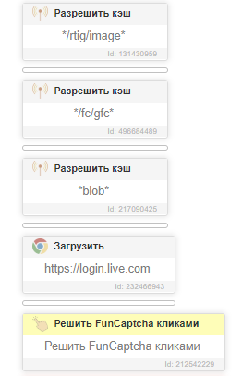

Instructions for solving TikTok captcha

***TikTok captcha*** is one of the easiest types of captchas presented in the module. Since the captcha is presented only on 1 site, then there should not be any difficulties in setting it up.

The captcha solution is quite simple :

1. *Create cache* . We need to create a cache from where we will get the image. You need to go to the ***Network >perform an action: Enable cache*** and create 3 such actions with the following mask: ***\*ibyteimg.com*, * ibytedtos . com *, * captcha *.*** These actions must be placed at the beginning of the template. For example, before the Tik Tok website was loaded.
2. *Call an action with a module that solves the captcha. As soon as you see the captcha, just call the actions of the module, it will select the selector itself, click on the images, send them to the* captcha solving service . The module supports 3 types of captcha: drag the slider (a round captcha with two images), select identical objects in the image, and also move the slider and complete the puzzle .

**An example of solving captcha on the authorization form via mail and password**

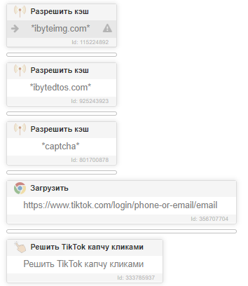

Instructions for solving GeeTest captcha

***GeeTest captcha*** - a captcha where you need to drag the slider in a given direction and thereby assemble the image into one single view. In version 4.0 of the module, a new type of captcha was added - where you need to sequentially click on several images specified in the task.

The captcha solution is quite simple:

1. *Create cache* . We need to create a cache from where we will get the image. You need to go to the ***Network >perform an action: Enable cache*** and create three actions with a mask: ***\*geetest.com/*/ bg * and *geetest.com/captcha*, as well as *geetest.com/ nerualpic *.*** These actions must be placed at the beginning of the template. For example, before we loaded the site where we want to solve the captcha.
2. *Select selector* . It is necessary to select a button selector on the site that opens a window with a captcha and place it in the selector field in the module settings. **Website example:**[*https://faucetpay.io/account/login*](https://faucetpay.io/account/login)

***Picture :***

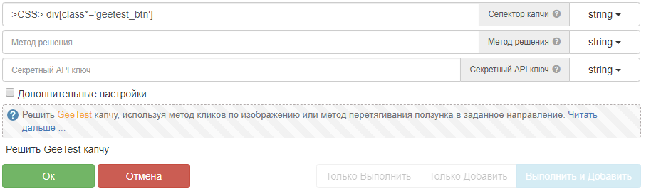

The default selector : *>CSS >div [ class *=' geetest _ btn ']* is suitable for most sites, but there are times when the site owner has changed the layout of the site and therefore you need to create a *button selector on the site that opens captcha with pictures.*

*Note: The module will automatically click on the selector you specified - it will open a window with captcha images and solve it. It will then return the result of the solution. You do not need to press anything additionally yourself and you do not need to open the captcha either !!!!*

**Please note** : there are times when captcha may appear randomly on your site, for example, only if you use low-quality proxies. An example of such a site:

[***https :// ascendex . com / en / register***](https://ascendex.com/en/register)

If the captcha does not appear with a 100% chance, then use the action **to check the existence of the element, and only if the captcha exists, start solving it with the module.** In this scenario, it is NOT required to specify a captcha selector, it is enough to check the open captcha window on the page.

**An example of a selector for the check existence action:**

*>css > . geetest_window _ _*

**To summarize, below is a screenshot of how to solve GeeTest on the website** [*https://faucetpay.io/account/login*](https://faucetpay.io/account/login)

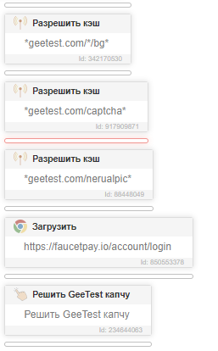

Instructions for solving YandexSmart captcha

***YandexSmartCaptcha***- captcha, where you need to recognize the numbers and letters in the image in the browser, and then enter the answer in a special field on the site, and then confirm the solution. In the new versions of the module, another new type of captcha has been added, where you need to sequentially click on several images specified in the task. At the moment, the module can solve 2 different types of this captcha .

At the moment, this is the easiest type of captcha in the module, and you do not need to create any cache masks, compose complex selectors, delve into additional settings, and so on.

***The captcha solution is quite simple:***

1. *Open captcha form with " I'm" buttonnot a robot " ("I'm not a robot").* Use this selector to check if this captcha appears in your browser : **>CSS >input [ class *=' CheckboxCaptcha-Button ']**

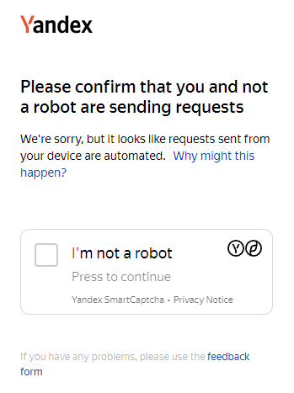

1. *Call an action with a module that solves the captcha .* Thenthe module will automatically click on the selector you specified - it will open a window with captcha images and solve it. It will then return the result of the solution.

***Final solution example***

